**Assignment – 2**

* **Connect to the Store Sales Data and do the following: -**
  + *Remove all the blank rows.*

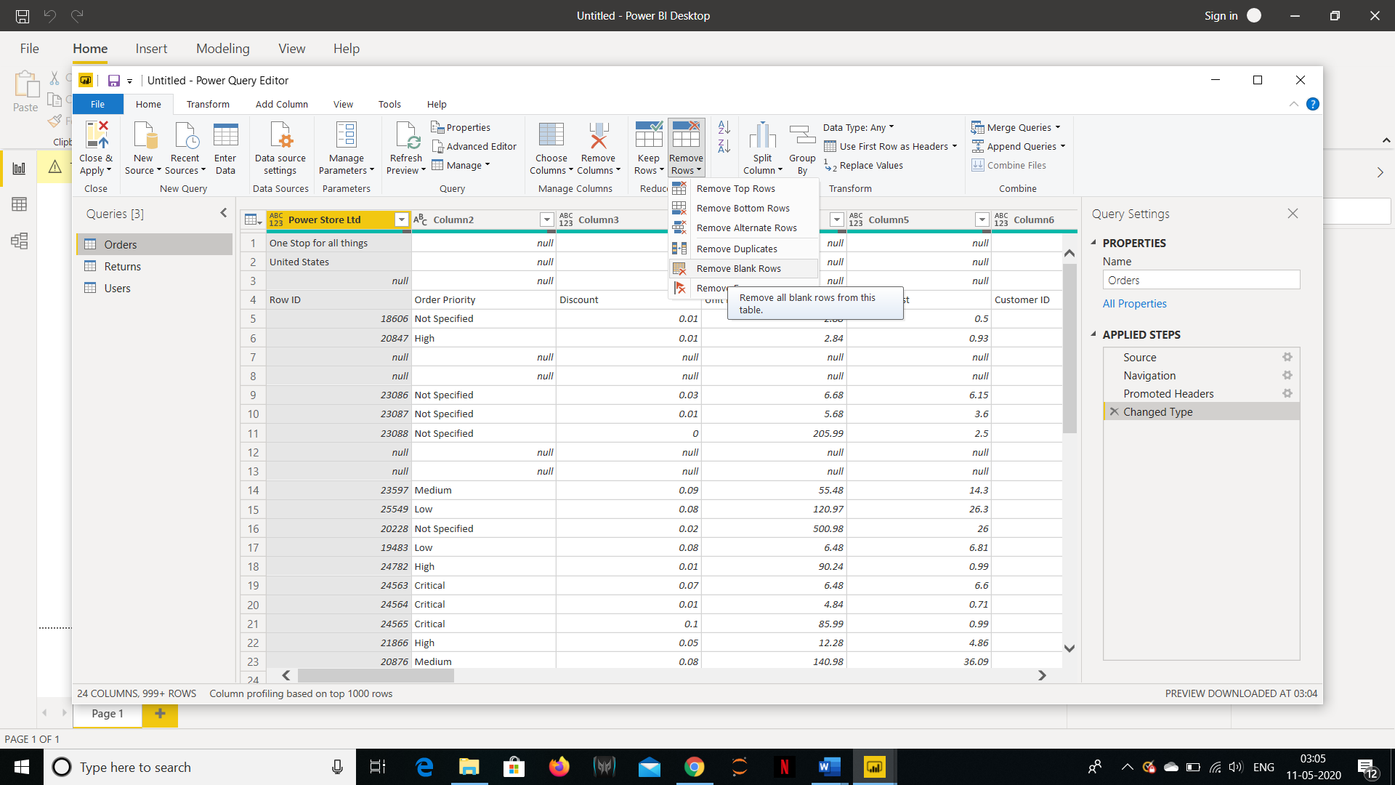

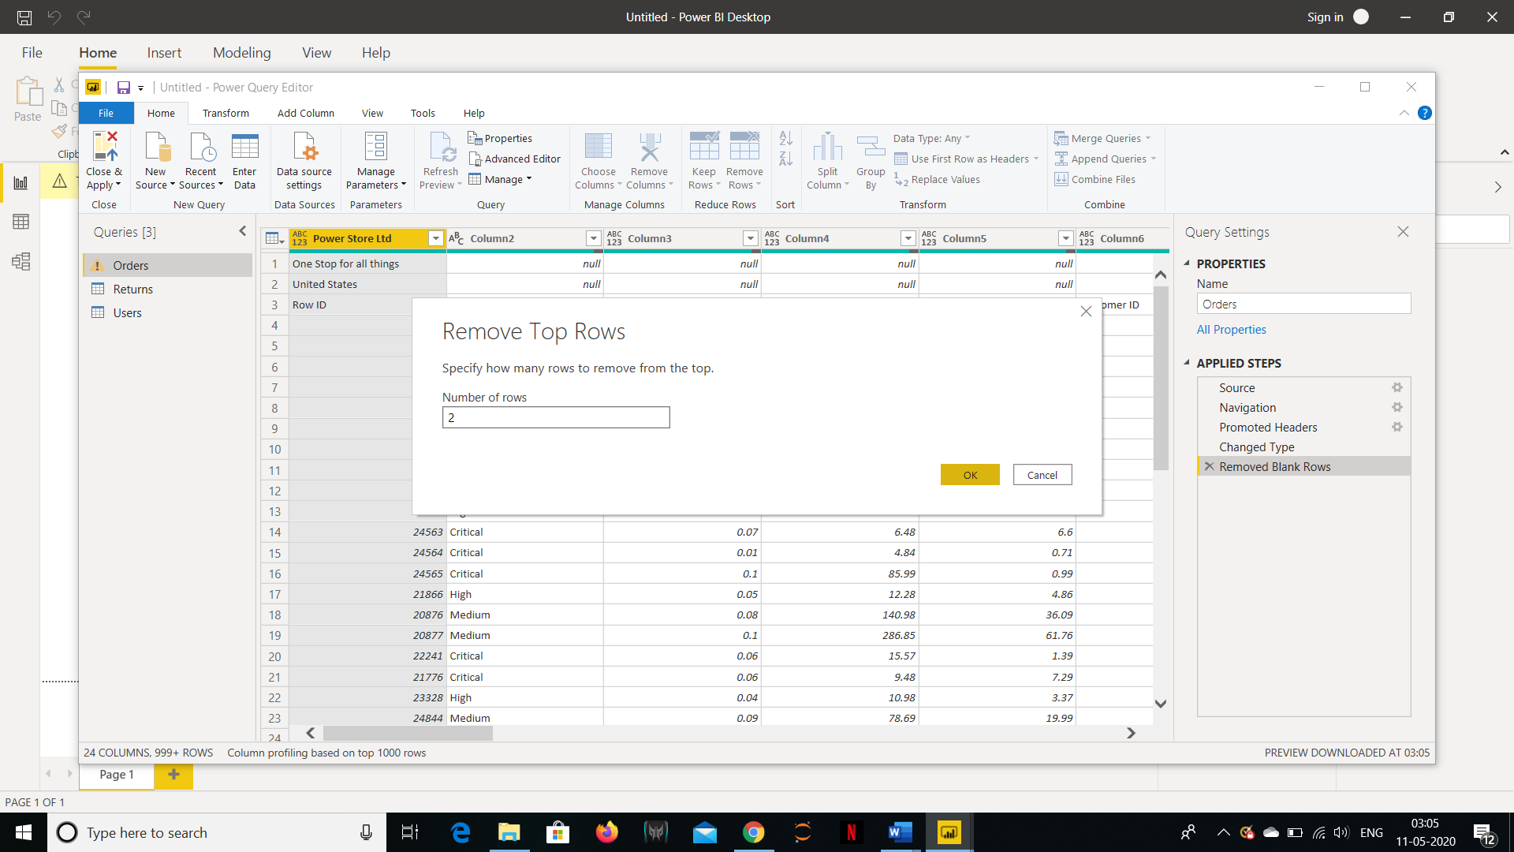

* + *Update the column header if they are not updated*

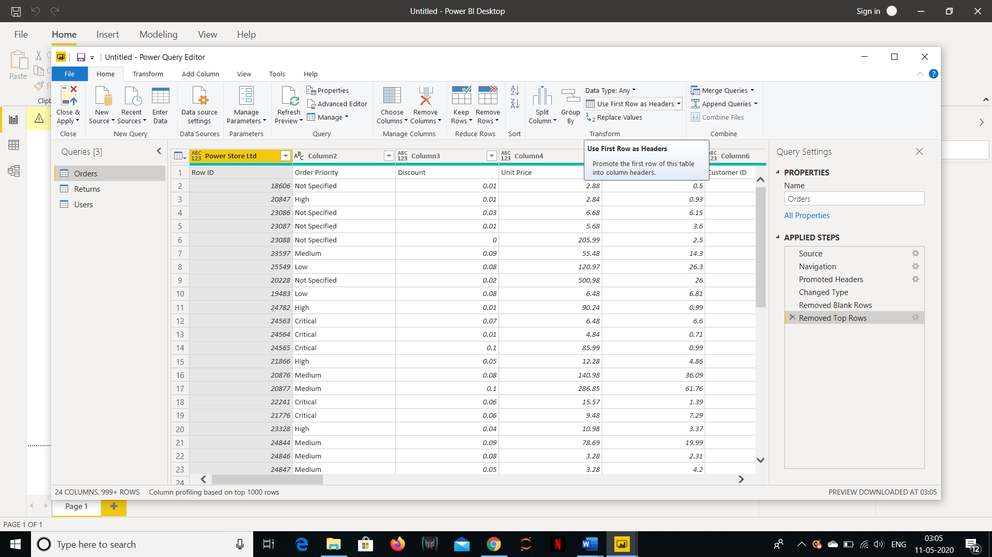

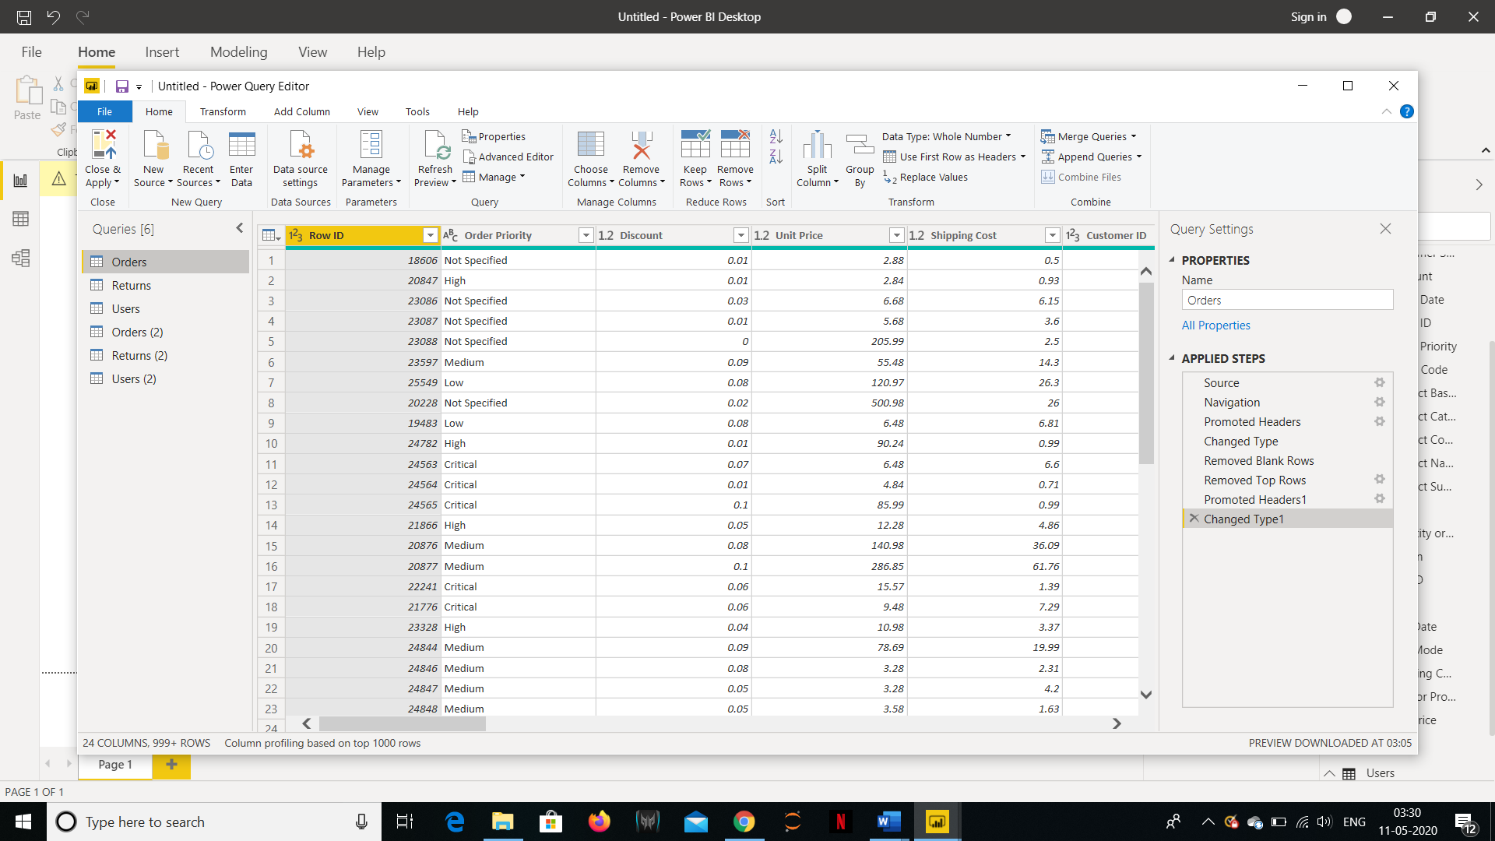

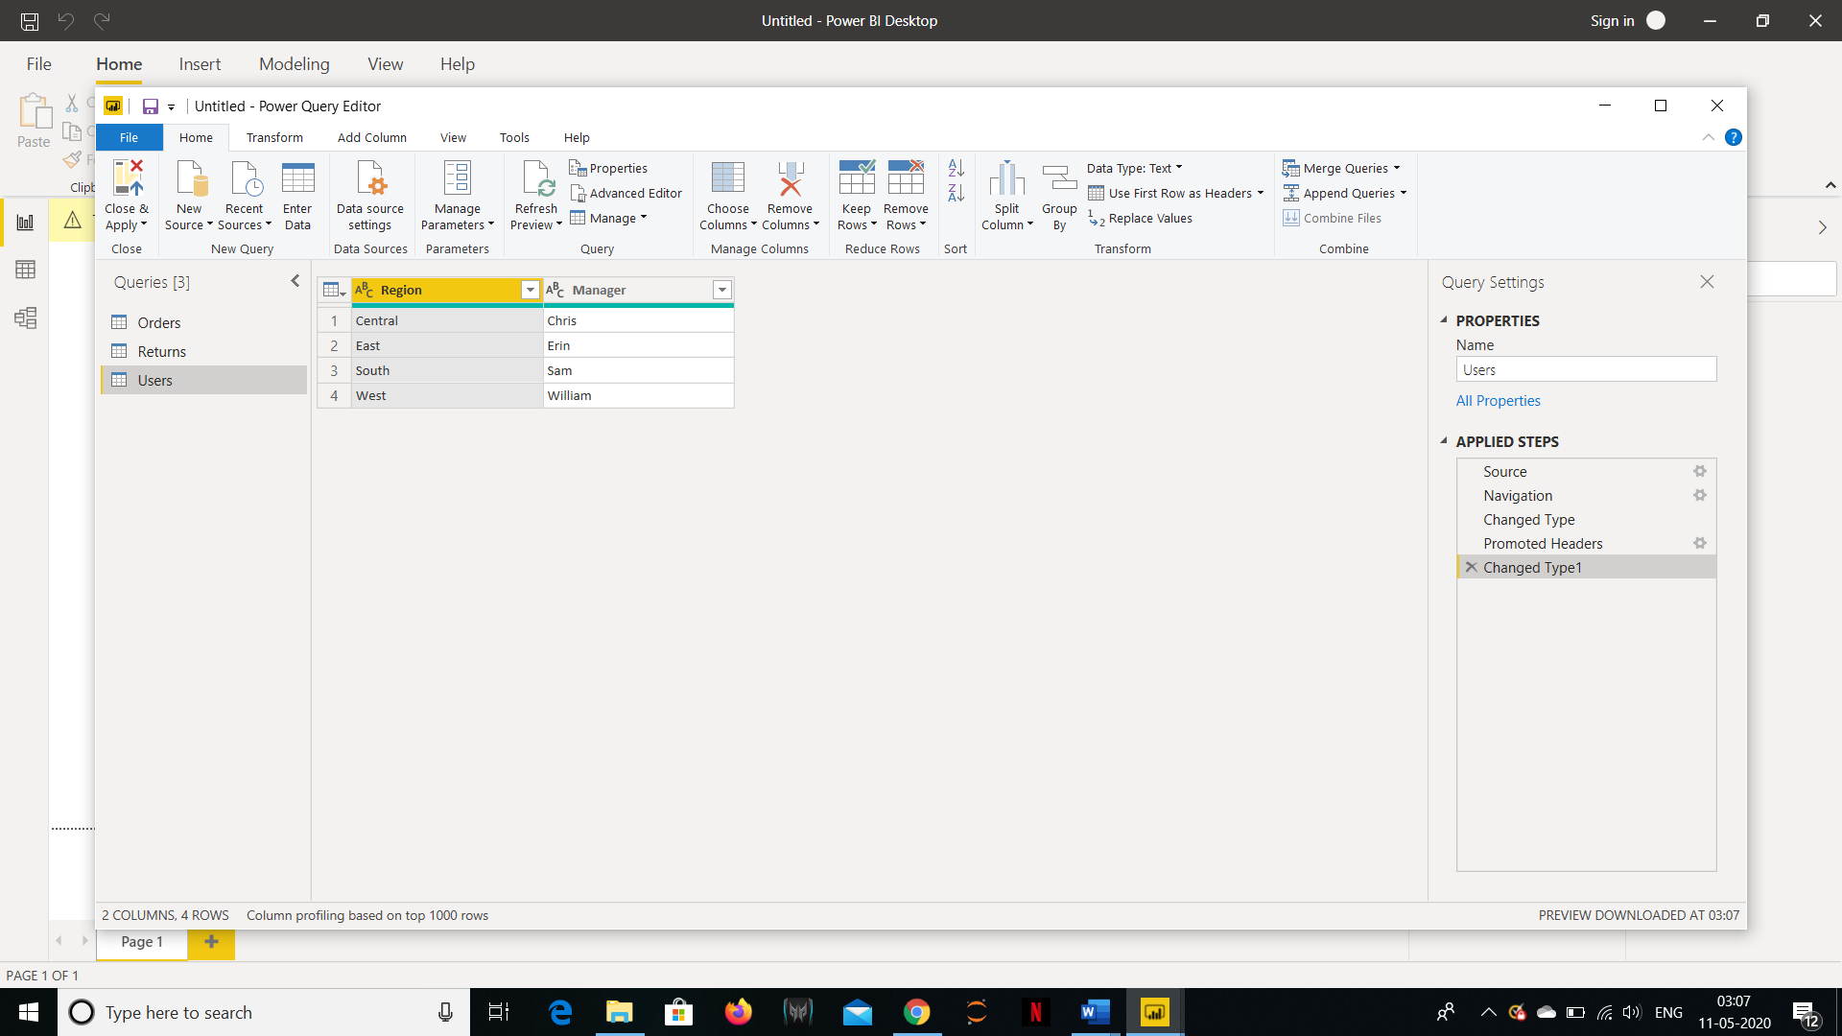

* + *Create a text table and show the sales in terms of*
    - *Customers*
    - *Product category*
    - *Regions*

*(Sorted on the basis of sales)*

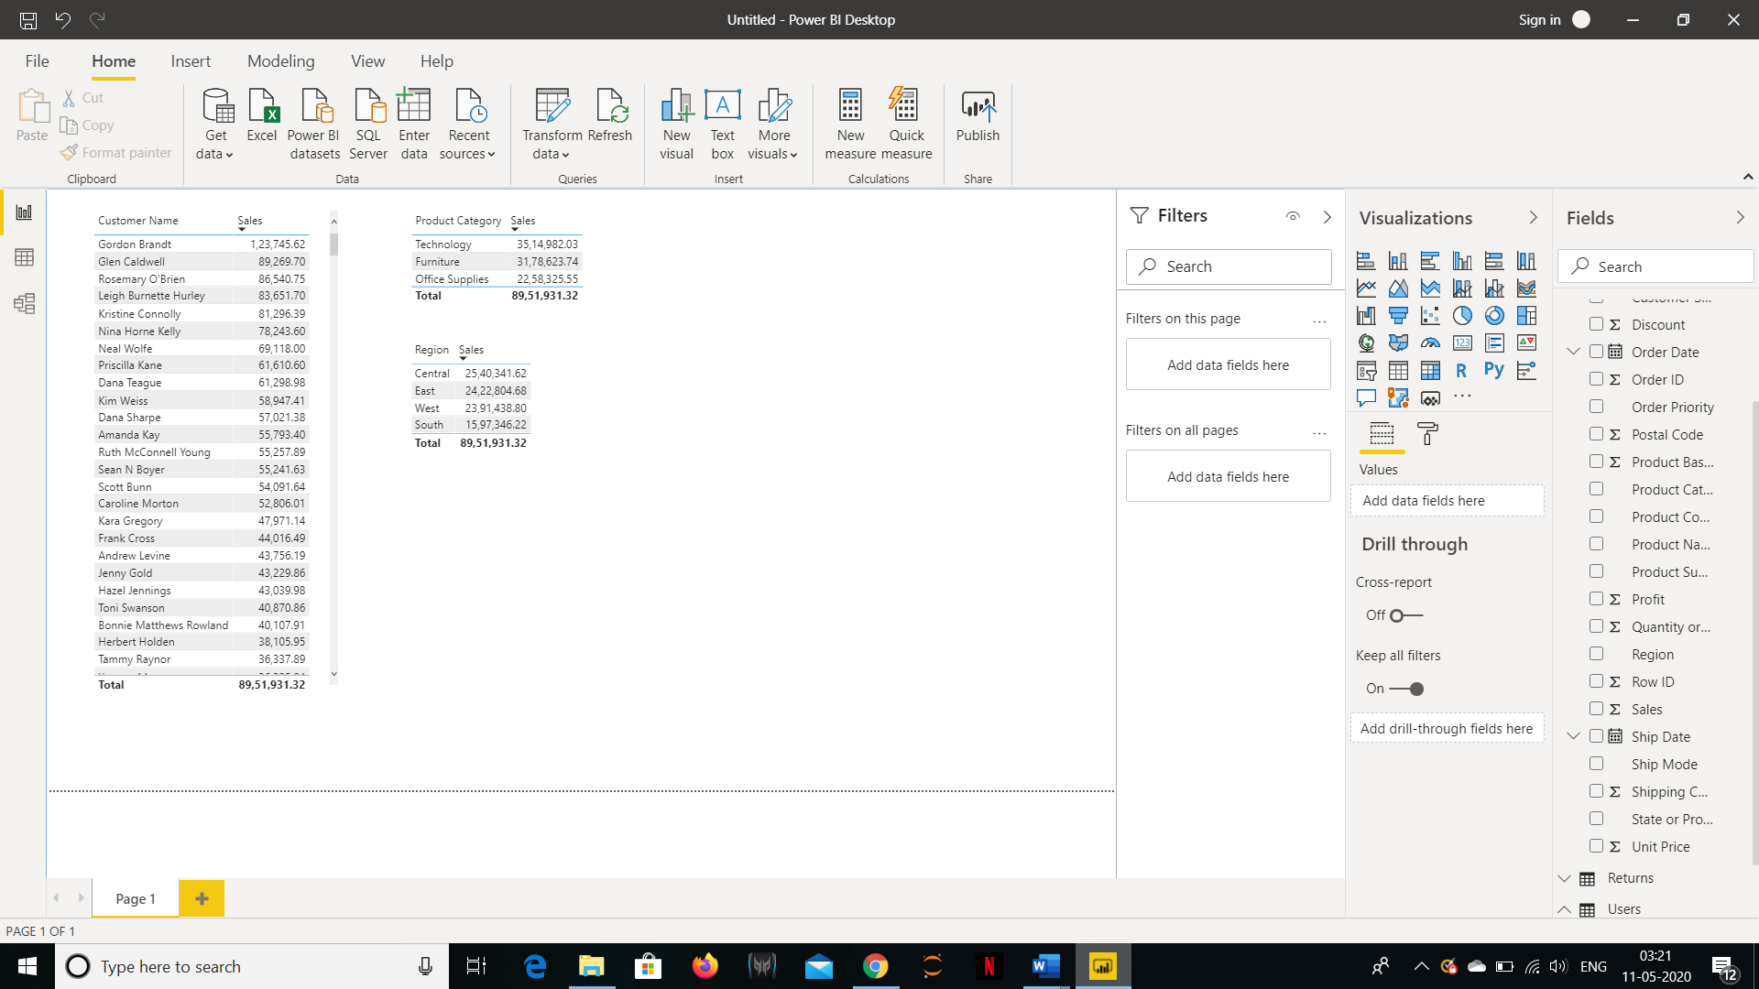

* **Create a Line and Clustered Column Chart showing the Sales and Discount as per the State or Province :-**

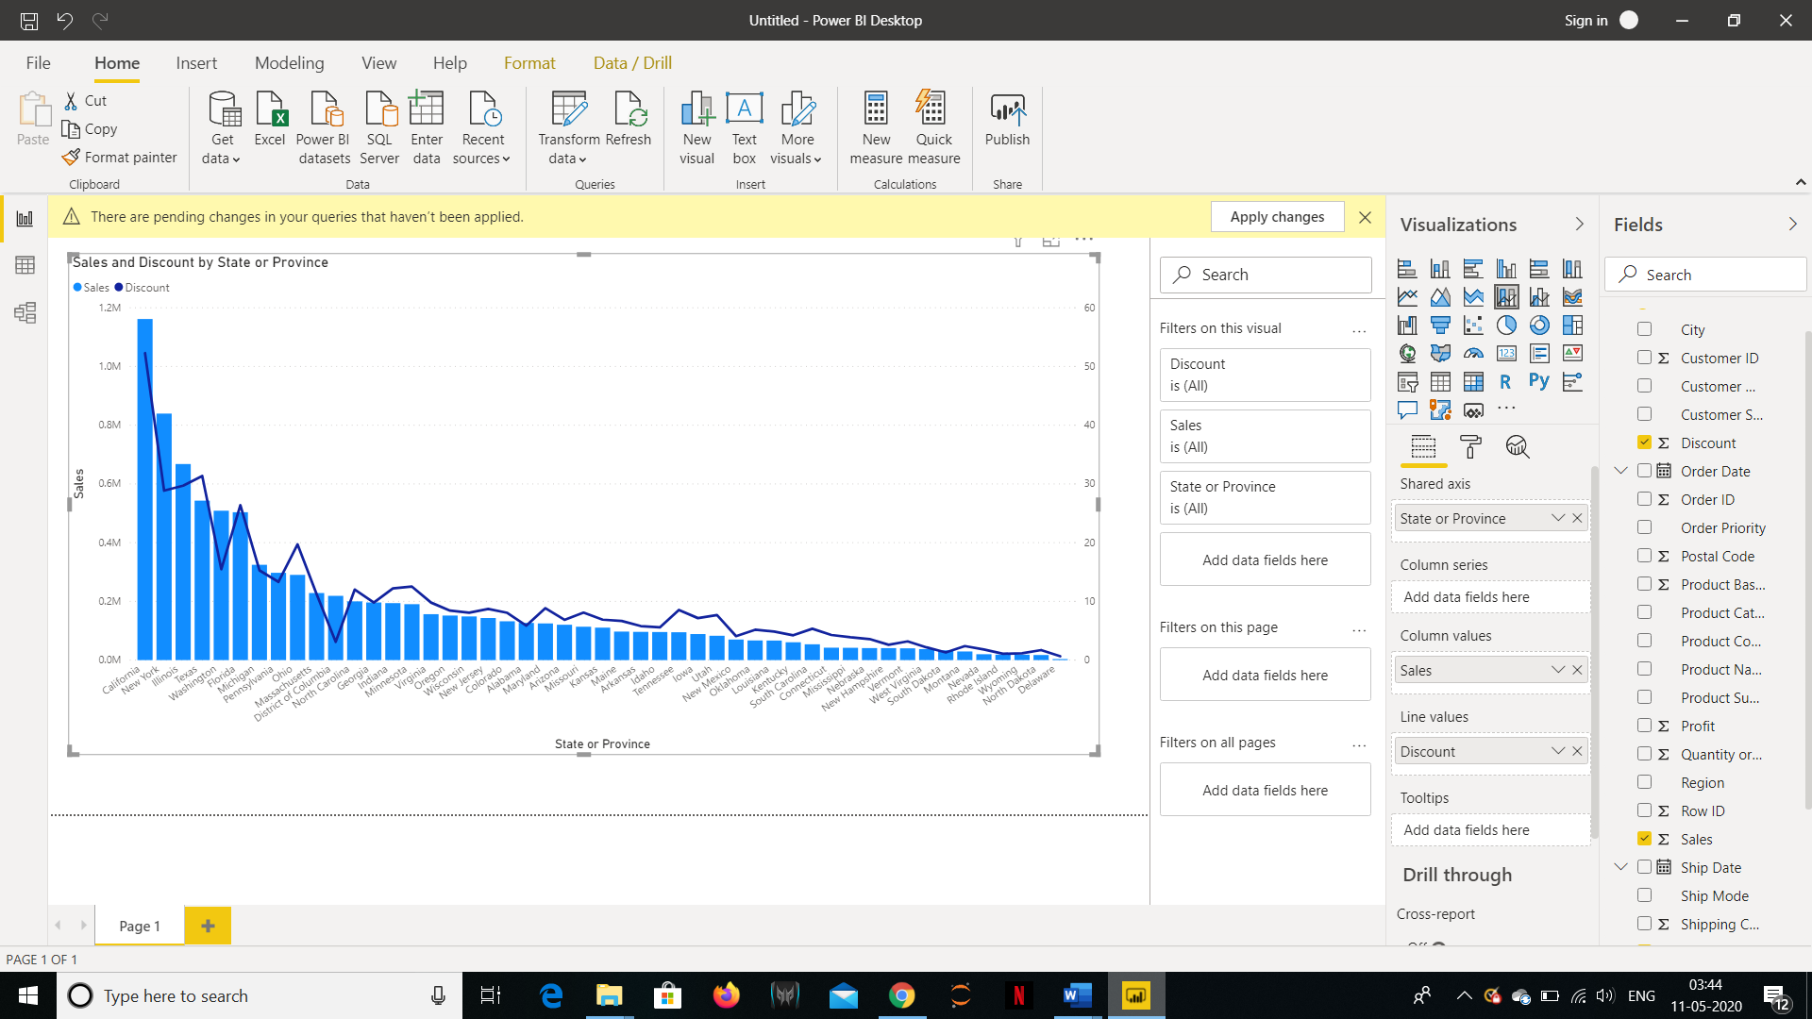

* + *Format the bars and line with different colors*

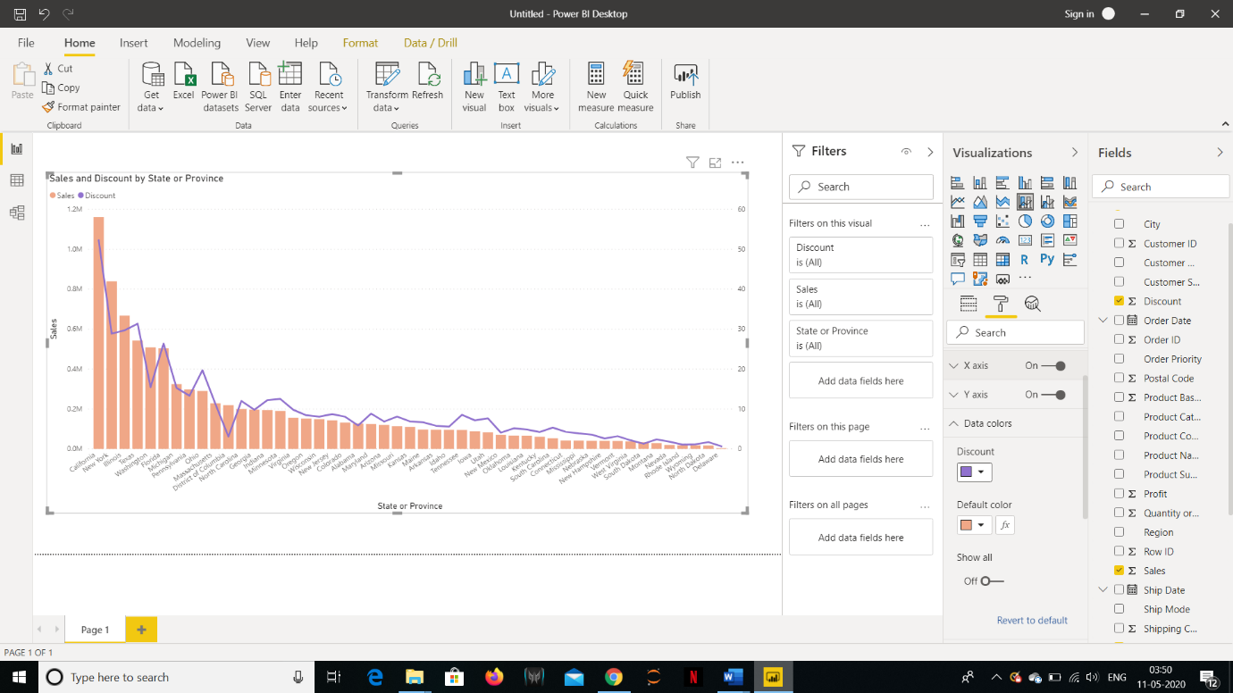

* + *Which state has the highest sales in terms Technology*

*(New York with 3,97,019 sales in Technology)*

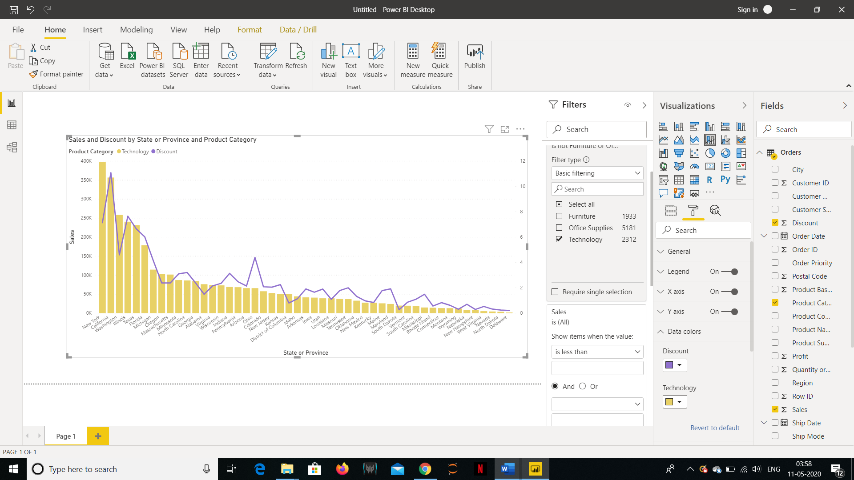

* **Create a Donut Chart****showing sales in terms of Product Category :-**

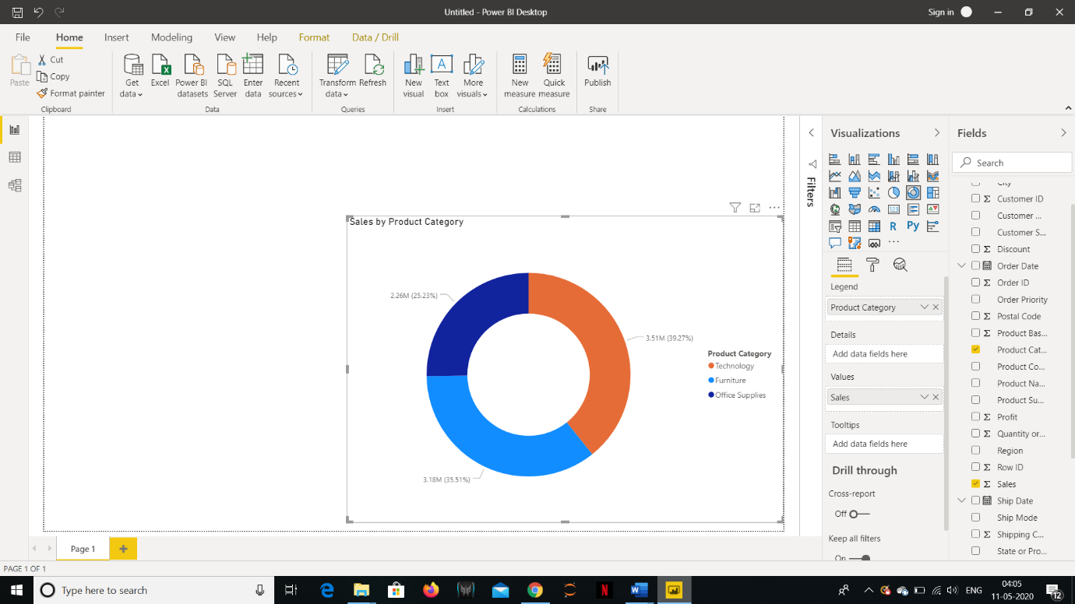

* **Create a Slicer****and show the regions in dropdown. See how all the visuals mentioned above behaving when a particular region is selected :-**

